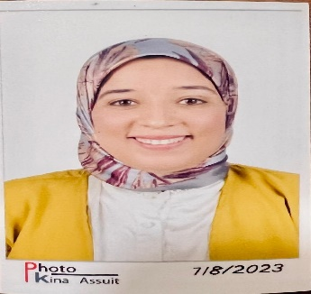 |  | Shaimaa ali mohammed
NATIONALITY  Egyptian  city  sohage  BIRTH  1April 1991  marital status  Married, 1 children.  Contact  PHONE:  01016599093  EMAIL:  drshimaalimohammed@gmail.com  LINKED IN:  LANGUAGES  Arabic:  Excellent (Mother tongue).  English  computer skills  Work on computer systems |  | EDUCATION  Assiut University Egypt  Bachelor of medicine and surgery  2008-2014  Master Degree in chest diseases and tuberculosis  2016-2020  PHD in chest diseases and tuberculosis  2020 -til now  WORK EXPERIENCE  Assiut university hospital (egypt) JCI accredited.  Resident doctor in chest department (64 Bed)  and respiratory ICU (22 Bed) from 2016 to 2020.  Assistant lecturer at same place from 2020 till now.  certificates  -BLS Provider (2015 – 2017) American Heart Association  -ACLS Provider (2020 – 2022) American Heart Association  Skills
  - Management of critical patient in respiratory ICU
  - Intubation.
  - adjust ventilatory settings.
  - Insertion of central venous line (CVC).
  - Chest ultrasound.
  - Pleural aspiration (Pleurocentesis)
  - pleural biopsy.
  - Pulmonary function interpretation.
  - Sleep report interpretation.
  - Bronchoscopy in mechanical ventilated patients
  - Teaching of pulmonary medicine.

